Palmerston Road,
FAIRFIELD WEST 2165
Tel.: (02) 9604 5568
Fax: (02) 9725 5379
Fairfield West Public School
6 June 2019

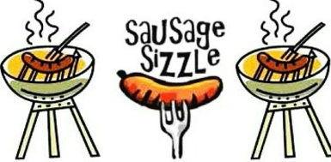
Barbecue Wednesday 12 June, 2019

Dear parents and caregivers,
As part of their fundraising efforts, Year 6 will be holding a sausage sizzle on Wednesday 12 June. Students may order a sausage sizzle $2.00 and a drink $2.00 and these will be delivered to classrooms for lunch. Students must order by Tuesday 11 June by returning the order form below and money to the office. Thanks in advance for supporting our fundraising efforts.

Ms G. Goldfinch  Principal | Ms Mah Chut  Assistant Principal

----------------------------Please return to the office by Tuesday 11 June --------------------------------------

Barbecue

Name: _____________________________________ Class: ____________________________

Quantity | Product | Unit Price | Total
 | Sausage Sizzle Halal | $2.00
 | Sausage Sizzle Beef | $2.00
 | Sauce | Free
 | Creaming Soda Drink | $2.00
 | Passionfruit Drink | $2.00
 | Lemonade Drink | $2.00
 | Lemon Drink | $2.00
 |  | Total enclosed:

