Important Change of Date
Cross Country Carnival 2022

Dear parents and caregivers,

Our Cross Country Carnival for years 3-6 will be held on Thursday 5 May 2022 at Avery Park, Fairfield West. Year 2 students who are 8 or will be turning 8 this year will have the opportunity to attend and compete at the carnival.

Students will leave the school at 9.30am and return by 3.00pm. Students may wear their house colours and suitable shoes for running. Students aged 8, 9 and 10 will be required to run 2000m and students aged 11, 12, 13 will be required to run 3000m.

There is no cost for the carnival as students will be walking to Avery Park with a teacher.

All staff members are trained in emergency care and CPR.

Student lunch orders will be sent to Avery Park. If ordering lunch, please write your child’s name, class and house group.
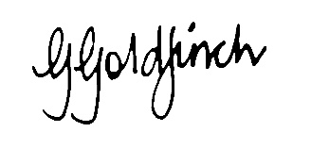

Ms G. Goldfinch Mr R. Hormis/Mr D. Ottmann
Principal Sport Coordinators
29 April 2022

--------------RETURN BY Wednesday 4 May 2022 to classroom teacher -------------------

FWPS Cross Country Carnival 2022

I understand that my child _______________________________of class ________ will attend the Cross Country Carnival at Avery Park, Fairfield West on Thursday 5 May 2022.

PLEASE NOTE: In the event that the carnival is postponed, a back-up date will be scheduled.

Parent/caregiver’s signature: ________________________ Date: __________________

